**Points To Discuss (TechMandal):**

-Style 8 background engulfs the Title (looks bad)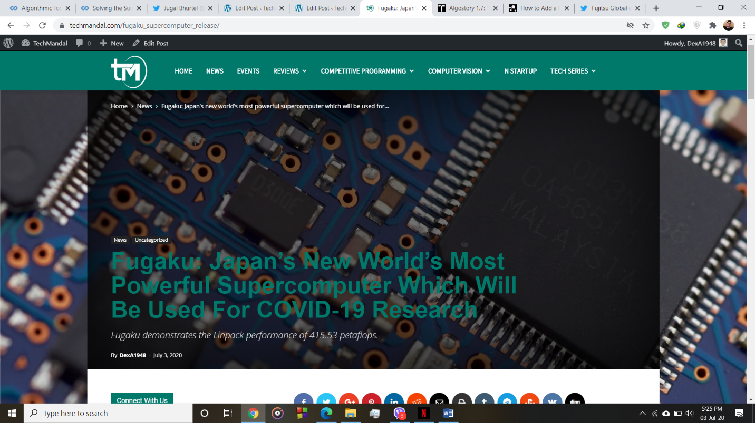

**-permalinks should be well defined**:

For e.g.: for news use, <http://techmandal.com/news/(title)>

And <http://techmandal.com/news> should show all the news in one place or redirect to <http://techmandal.com/category/news> for comfort

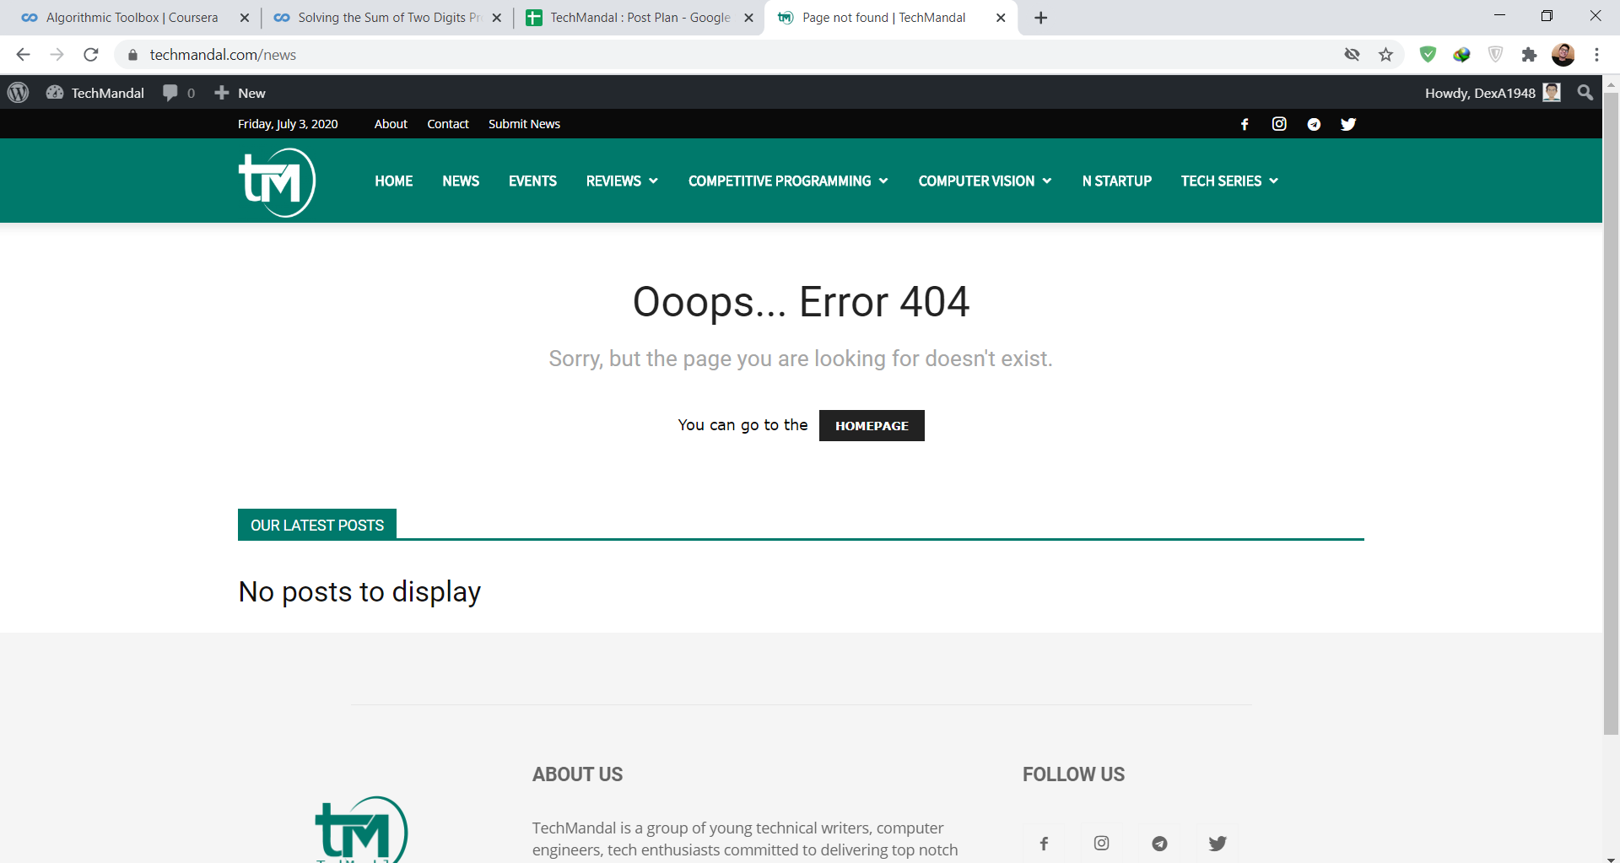

**-to use separate background image and featured image and make use of background image in other styles too.**

For style 8; the featured image (image that shows in embed and as a cover photo) also works as background image, due to which if we use non relevant or decoration images that will show up as embed or cover photo.

Style with a separate background and feature image can help, that option is not available in edit in our word-press.

**-Current themes have very slight contrast for different sections due to which main article doesn’t pop up as it should. (Looks bad and not well defined) described in a video**